If we have an expression tree and we want to evaluate that tree in order to compute the value of the expression, we want to evaluate the children before evaluating the arithmetic operator at an internal node. What traversal method does this mean we should use?
Sample expression tree representing (5−3) + (6×2):
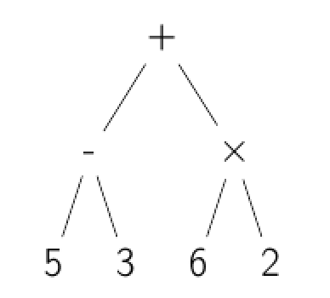
Post-order
Correct
Correct. In a post-order traversal, we evaluate all children fully before evaluating a node itself.
In-order
Pre-order
Breadth-first

